1.INTRODUCTION

* 1. **Overview**

**Group Leader**:

JAYA LAKSHMI PRIYA P

**Group Members:**

1.AASHIKA R

2.AASIMA THASNEEM A

3.MERWIN PRAISY A

4.NAGANANTHINI G

**1.2 Purpose**

Our topic (Charting the course of Innovation: A Startup Performance Analysis) helps us to get knowledge about how to startup a business and lead it in a successive way.

2.Problem Definition & Design Thinking

**2.1** **Empathy Map**

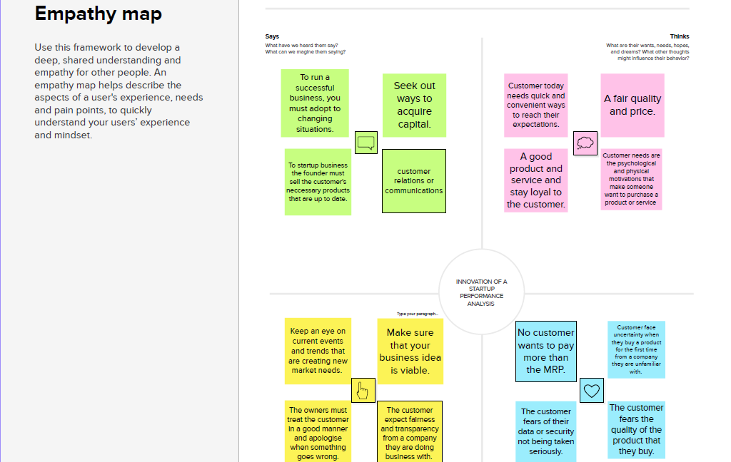

**2.2 Ideation & Brainstorming Map**

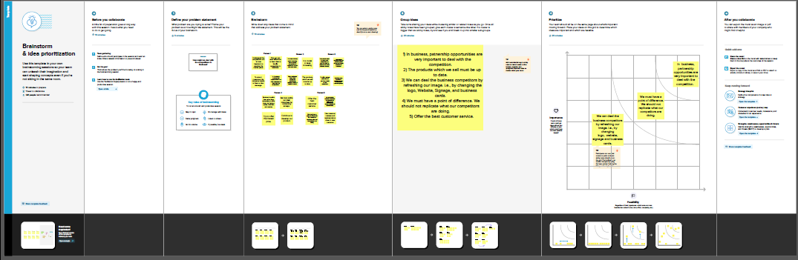

RESULT

Dashboard 1: 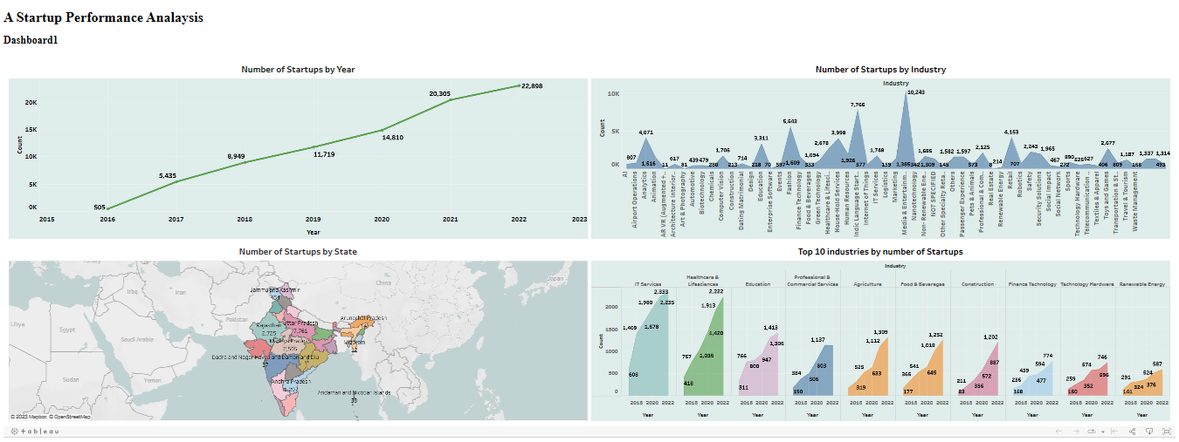

Dashboard 2:

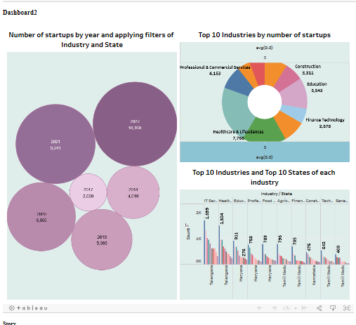

Visualisations:

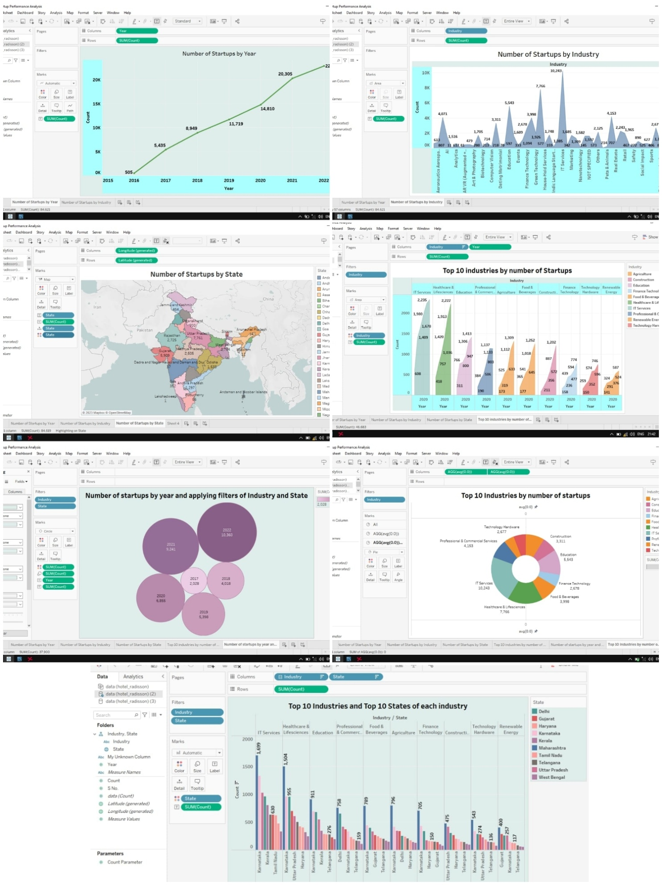

Stories:



ADVANTAGES & DISADVANTAGES:

1. **ADVANTAGES:**

Financial rewards.

Lifestyle independence.

Personal satisfaction and growth.

Team culture.

Personalisation.

1. **DISADVANTAGES:**

Financial risks.

Time commitment.

Risk.

Compensation.

Stress.

**APPLICATIONS:**

Modern organizations need to adapt a well planed innovation strategy: a set of systemised actions, behaviours, policies and procedures that work toward achieving a specific competitive goals and lay the groundwork for ongoing corporate evaluation and advancement.

**CONCLUSION:**

A business plan conclusion is a summary of a business plan’s strengths designed to convince the reader of the company’s success**.**

**FUTURE GOALS:**

1. Re-evaluating our current position in the larger ecosystem.
2. Measuring the relevant of business against the new context.
3. Assessing agility to meet the expectations.
4. Identifying further opportunities for collaborations, partnership, and inclusion to effectively mobilize people.
5. Realigning priorities to support the vision.

**APPENDIX:**

1. **Source Code**

